The Unofficial Sinclair C5 Service Manual

The Sinclair C5 Electric Vehicle





P.J. Milner P. Newman
Sinclair Vehicles Sinclair Research
Coventry England Cambridge, England
Roy Woodward
Sinclair C5 Enthusiasts
http://www.sinclairc5.com

Table of Contents

The Sinclair C5 Electric Vehicle 3
Abstract 3
Introduction 3
Legislation 3
C5 Development 4
Electrical System Design Philosophy 4
Motor Protection 5
Battery Protection 7
Manufacture and Test 9
Instrument Pod 9
Control Box 10
Finished Vehicle 11
Performance Characteristics 12
Acceleration and Braking 12
Range 12
Gradability 13
Safety Engineering 15
Primary Safety 15
Secondary Safety 16
Notes on C5 Motor/Gearbox Assembly 17
Notes on C5 Instrumentation 19
Application of C5 instrumentation system to other vehicles 25
Reliability 25
Instructions for setting up the offset pot VR1 in the instrument pod 26
Known Problems with the C5 27
Replacement Parts 28
Accessory Instructions 30
Direction Indicators 30
Horn 33
High-Vis Mast 36
Mirrors 38
Mud Flaps 39
Seat Cushion 40
Seat Booster Pad 42
Side Panels 43
Tonneau 44

The Sinclair C5 Electric Vehicle

Abstract
The Sinclair C5 represents the first commercial attempt to produce an electrically powered vehicle in high volumes. In the electrical and electronic aspects of the vehicle, as in most other areas, minimization of component and assembly costs was a vital part of the design exercise. In many instances, a traditional EV approach had to be abandoned and design /construction techniques more closely allied to the light electronics industry were adopted.
The paper covers the development of the essential protection systems for battery and motor, the user instrument display and its associated semi-custom integrated circuit, the selection and testing of the cost critical motor power control system, the packaging of the electrical/electronic components into a form suitable for mass-production, and the battery charger design.
Vehicle technical data, including performance and operating characteristics are presented and discussed. Road load is quantified in terms of three constituent parts (mechanical, aerodynamic and gradient resistances) and is compared with the available tractive effort over the full vehicle operation range.
Illustration of the effects of various parameter changes are given with particular regard to the efficiency of utilisation of available battery energy and to operating range.

Introduction
The Sinclair C5 is a semi-enclosed three wheel power assisted cycle. It features a polypropylene body and weighs 45 Kg including a 15 Kg lead-acid battery. It represents the first attempt to produce, in high volume, a vehicle aimed specifically to comply with the electrically assisted cycle legislation introduced in the UK in August 1983.

Legislation
The UK does not currently enjoy the same liberal attitude to low-powered motor vehicles enjoyed by many of its European neighbours. Thus, even the lowest power mopeds require registration, road tax, insurance and a driving licence.
As a result of activity by certain interested parties, and after tests and recommendations from the UK Transport and Road Research Laboratory, a new category of electrically assisted vehicle was legally defined in August 1983. The key features were:
- Two or three wheels with pedal propulsion
- Maximum weight of 40 or 60 Kg, depending on vehicle configuration
- Maximum motor continuously rated output, 200 or 250 Watts, depending on vehicle configuration
- Maximum powered speed 15 mph (24 kph)
In addition, this class of vehicle could be driven by any one of 14 years of age and over. It did not require a licence, insurance or road tax. Furthermore no protective helmet had to be worn.
As a result of the legislation, several companies have begun to offer electrically assisted machines. These are predominantly based upon existing bicycle layouts. The C5 is the first example of a purpose designed three-wheel, semi-enclosed vehicle to appear. (see Figure 1)

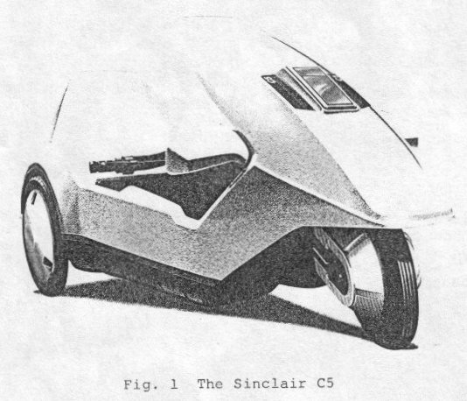

C5 Development
Sir Clive Sinclair, as founder and chairman of Sinclair Research Ltd, has designed and marketed a range of personal computer, TV and other electronic products. Sir Clive's long-term personal interest in electric vehicles had resulted by 1983 in the construction of a number of prototype single-seat machines. These demonstrated the feasibility of meeting basic performance requirements, of speed and range, using existing battery technology. By adopting a single seat configuration, minimising weight and maximising efficiency, a realistic performance could be achieved. These developments were the basis of the C5.
Working capital for the project was raised through the sale of a 10 per cent shareholding in Sinclair Research Ltd, to various institutions. The Sinclair Vehicle Project, under the direction of the future managing director, assembled a project team to undertake the development. The team included numerous sub-contract organisations and individuals as well as potential component suppliers. Foremost amongst these was Lotus Cars who undertook chassis and transmission development. A total of some 100 individuals contributed to the development over a concentrated 12 month period culminating in pre-production prototypes and fully committed tooling by the middle of 1984.
The C5 will now be described in terms of its EV design parameters, manufacturing requirements and performance characteristics.

Electrical System Design Philosophy
C5 was designed to be used safely without prior instruction by a spectrum of users from 14 to 92 (the oldest to-date) years old. With the younger age group in particular, an element of deliberate abuse was expected and the electrical system design had to cater for this. In addition, essential component supplier liability could not be imposed without protection. In particular, the motor had to be protected from thermal overload and the battery from over discharge or incorrect charging. Furthermore, a battery master switch, circuit fusing and weather protection were all deemed necessary.
Figure 2 shows a block diagram of the C5 electrical system. It comprises:
- An instrument pod with visual user displays of battery state of charge and motor load. An audible warning is provided for low battery and motor overheat, before protection systems operate.
- The control box housing the system interconnections, motor control relay, current shunt and miscellaneous components.
- The motor armature temperature sensing probe and back-up system.
- The battery connector and manual cut-out.

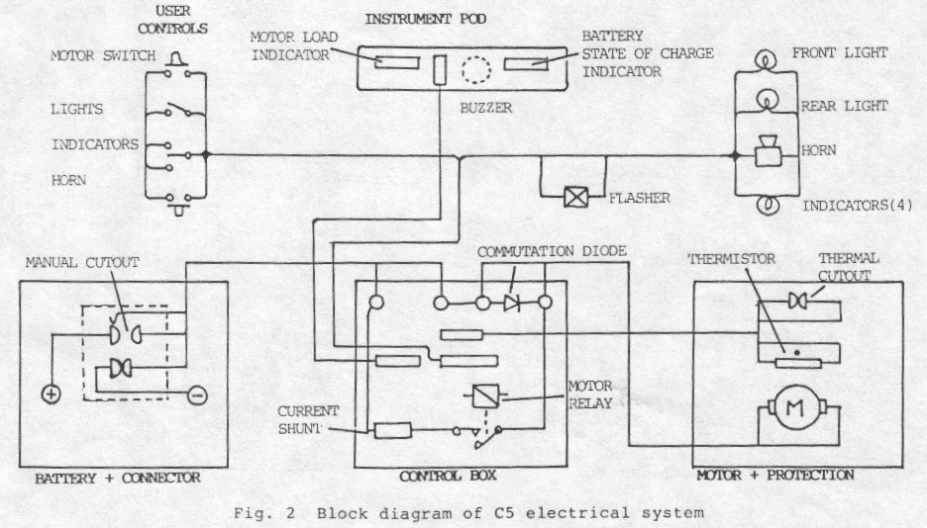
The following sections deal with particular aspects of the electrical system in greater detail.

Motor Protection
With legal weight restrictions and a target manufacturing price set, it was considered unnecessary to include any form of proportional motor control. A permanent magnet motor was chosen as allowing the legislation on powered top speed to be met simply by having a defined maximum no-load speed on the motor. High stall torque was considered important in achieving good hill climbing performance and rapid acceleration, the latter to give a measure of traffic compatibility for town use.
Given these decisions it was vital to protect the motor from thermal failure caused either through deliberate misuse or excessive overload. Three approaches were considered:
1) A mathematical model of the motor was proposed to using lumped constants (determined experimentally). The model was to be implemented using analogue circuit techniques in integrated form. However, it was found that without some form of real temperature feedback, the technique could generate significant errors when low rates of rise of temperature occurred. It also proved difficult to implement with any accuracy using the integrated circuit elements available.
2) A study and significant practical experimentation was made of a real thermal model using a resistive heater to simulate armature dissipation and a metal block surrounded by thermal insulation. The model included a thermistor whose resistance indicated the expected armature winding temperature of the motor. By mounting the model firmly to the motor case, the required feedback was obtained to eliminate long-term drift problems.
Although were a number of successful models were built, they would have been difficult to reproduce with sufficient repeatability and the effects of ageing on the thermal insulation were unquantified.
3) A still more direct measuring system using an non-contacting thermal probe was built which measured the air temperature inside a hollow portion of the armature shaft. It was considered essential to have a non contacting probe as project time scales precluded an extensive assessment of the wear characteristics of any rubbing seals.
Experiments showed good correlation between the deep armature temperature and that at the practical measurement point (Figure 3). The correlation was good enough to select this technique for the production C5.
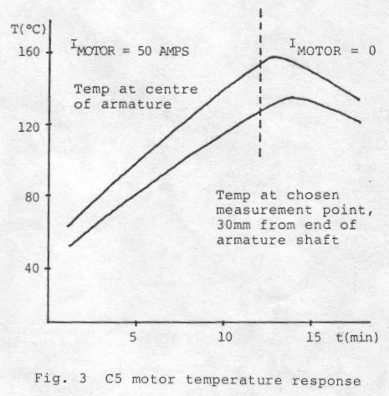
A close tolerance thermistor was used in the probe configured as a potential divider. In conjunction with two voltage comparators, the first level warning and a second level power lock out feature was provided.
The probe system was incapable of providing protection in the case of rapid overload such as a deliberate stall condition. To cover these cases an integration of current with respect to time was used. This has a characteristic as shown in Figure 4 and provides stall protection at 140 amps in a few seconds.
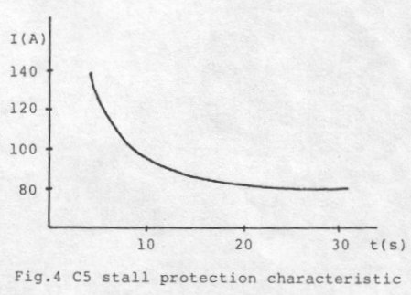
The final back up, a resettable bi-metallic trip is mounted on the motor case, breaking the motor relay coil current at 70 º C +/ - 5 º C.

Battery Protection
The C5 battery is a flat plate semi-traction lead-acid unit developed and manufactured for Sinclair Vehicles by Oldham batteries. The specification is as follows:
- Weight: 15 Kg
- Capacity at five-hour rate: 36 Ah
- Depth of discharge: 80 % of five-hour capacity
- Cycle life: 300 for 20 % reduction in capacity
To prevent over discharge, a technique incorporating a compensated terminal voltage measurement under load was used. Circuits employed are part of a semi-custom integrated circuit and these also provide a visible indication of battery charge in the form of a five segment bar graph display. The onset of battery cut-out is preceded by a 20 second audible warning period, in order to provide sufficient time to complete any ongoing manoeuvre and make vehicle and driver safe. A block diagram of the battery condition gauge is shown in Figure 5.
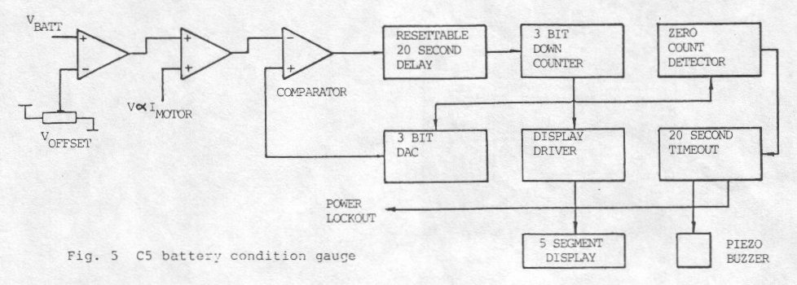
A nominal 18 milliohms of battery impedance is assumed. The gauge can only decrement and contains a 20 second delay which must time out before a display decrement can occur. This eliminates spurious counting. The five equal incremental voltage steps span the nominal voltage range, 12.0 to 10.5 volts. The inherent non-linear voltage profile of the battery (under constant current discharge) gives an non-linear display with time. It therefore provides ample warning of the end of available battery capacity, and in a pedal assisted vehicle is quite sufficient.
Correct charging of the battery is fundamental to achieving a long life. A form of two-stage constant current followed by a constant voltage charging profile is used. The battery can be charged in situ or it can be removed and taken to the charger.
The charging profile is shown in Figure 6 and is implemented by a hybrid circuit with laser trimmed resisters driving 2 SCR's as a phase controlled current source. The whole assembly is potted both to aid heat dissipation and to fully weatherproof the unit. To LEDs indicate charging active and finished. A charge time of typically eight hours is required from full discharge.

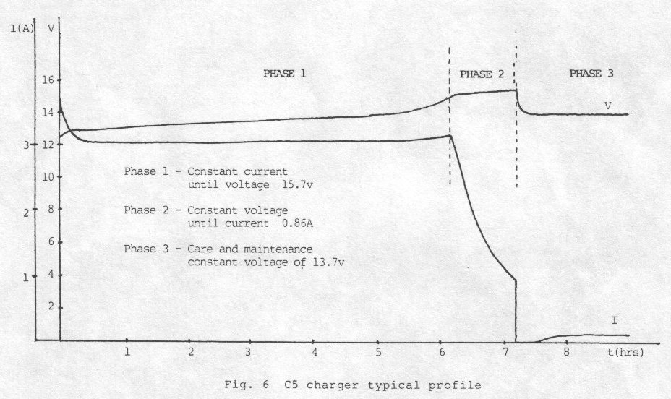

Manufacture and Test

Instrument Pod
The complete instrument pod is shown in Figure 7. It is tested in conjunction with an operator using automatic test equipment on a "bed of nails" fixture. The tests include voltage, current , frequency and time measurements to verify full functionality. The test time of approximately two minutes, which includes one operator adjustment, reflects the extensive functions provided by the semi-custom IC. There is a limit to the circuit speed-up factor that can be employed whilst still maintaining the measurement tolerances. The operator interacts with the test equipment and verifies correct display and of audible transducer operation.
After manufacture and test by a specialist sub-contractor, the circuit boards are mounted in the two-part polypropylene case and shipped to the vehicle assembly plant for installation under the C5 canopy.

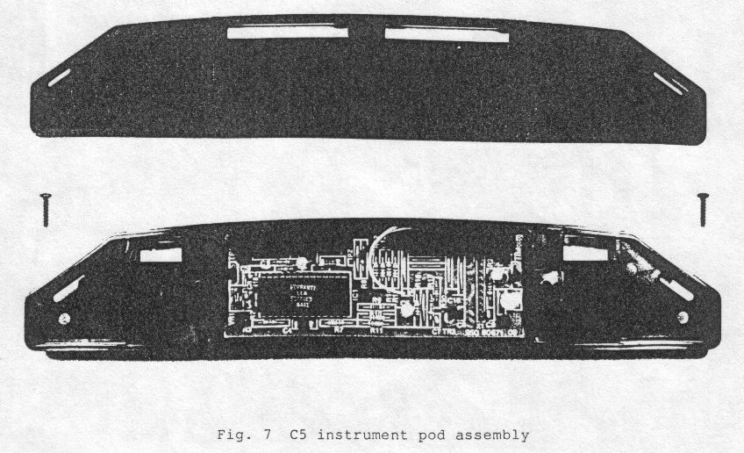

Control Box
The control box contains a mixture of high current motor circuits (up to 140 amps), intermediate duty systems for vehicle services such as lighting etc. and low-level signals associated with current measurement (1 millivolt/amp). Traditional electronic components are assembled and tested by a specialist sub-contractor (Figure 8). The power components are then added. These include heavy current interconnections using 4 and 5 mm hardware, with machine crimped ring and 6.35 mm spade terminals. The motor relay is a specially developed unit from Ital-Amec in Italy with a thermal rating superior to that of the motor. Contact arc suppression is vital and provided in the optimum circuit location by a rectifier diode rated at the Quorn amps. It's transient capability is more than adequate and reflects the reappraisal of "the fitness for purpose" approach adopted throughout C5. The relay is specified to withstand 10,000 make/break cycles at 140 amps, in the specified circuit configuration.
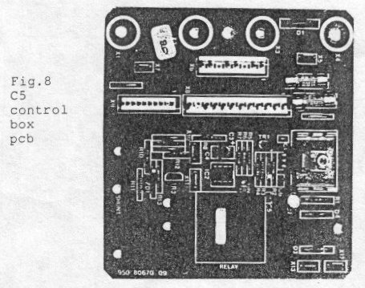
A current measurement shunt is provided for driving both the battery condition gauge compensation circuit and the user display of motor load. A simple stamping from a resistive alloy sheet, with a nominal resistance of 1 milliohm is used. Riveted power connections and 6.35 mm push-on sense leads are used. All motor wiring uses 6 square millimetre cross section wire insulated with automotive grade PVC. The continuous rating of this conductor size exceeds that of the motor by a substantial margin and provides the most cost-effective solution as low-cost machine crimped terminations can be used.

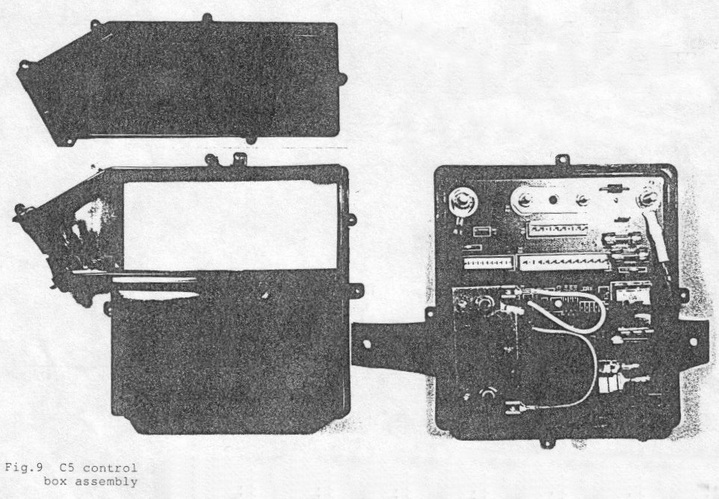
The finished control box PCB (Figure 9) is assembled into a two part polypropylene moulding plus access cover. The halves are ultrasonically welded together and combine a tamper-proof cavity with a user accessible portion where the heavy current connections to the vehicle wiring harness are made. Other connections plug-in before the access cover is added. A downward pointing cable entry and splash grommet ensure no ingress of water whilst allowing natural breathing to occur.

Finished Vehicle
The fully assembled vehicle is subject to a functional test at the end of the production line (Figure 10). Operator verification of instrument displays is the only manual intervention in an automated test sequence. The test includes:
- Motor no-load current
- Motor stall current and correct operation of stall protection
- Stall reset
- Motor load indicator functionality
- Battery condition gauge (no malfunction)
- Instrument pod current consumption
- Brake tests
An extensive quality audit test is carried out on a sample basis. After test the C5 is packed in its dispatch carton along with charger/toolkit/instructions and loaded directly on to a container truck for despatch to regional warehousing.
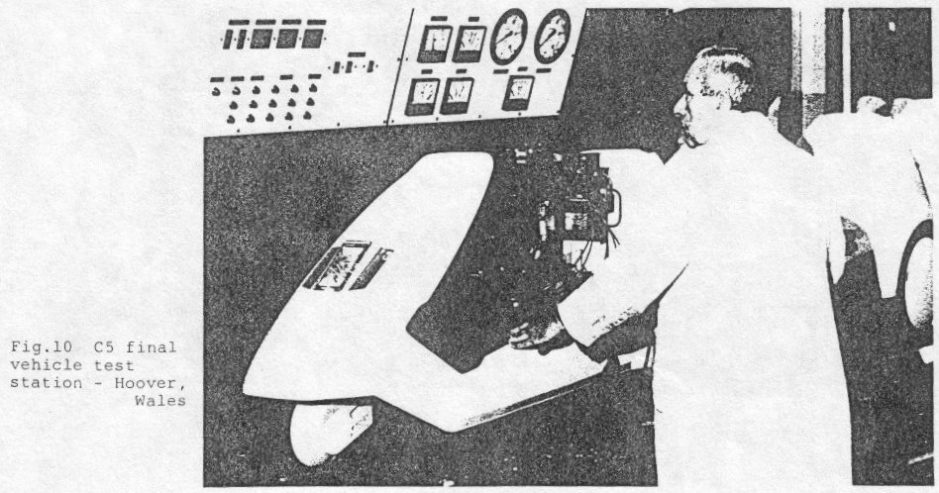

Performance Characteristics

Acceleration and Braking
Table I provides some basic dynamic properties with an average weight driver on board, and without pedal assistance. Low-speed acceleration is particularly lively, providing C5 with standing start performance equivalent to some small cars. These figures confirm the viability of the lead-acid battery for this class of vehicle, in which basic battery mass is typically only 15 % of gross vehicle mass.
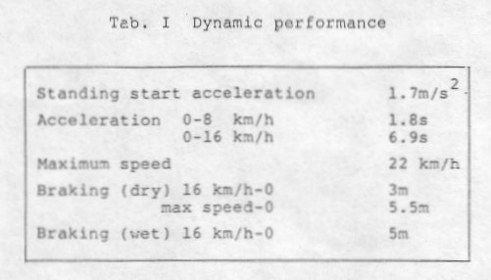

Range
The 35 Ah (at the 5-hour rate) battery provided with C5 delivers a useful 15 to 28 Ah in service on the vehicle, depending on the particular driving resistance present and the duty cycle imposed. Figure 11 shows how sensitive range is to the level of resistance present (proportional to current drawn) assuming the battery is discharged under steady driving conditions, and no pedal assistance. In order to provide a link with the on-board information available to the driver, current drawn is also depicted in the figure in terms of the motor load indicator information available while driving. Thus, if it cruise the motor load indicator sits in the right most green segment (with perhaps occasional and equal excursions into the left most green and amber segments) then the expected range on a single battery would be approximately 13 miles (21 km). As the capability exists to carry two batteries, also shown in the figure is the range available from two batteries when discharged separately, and when connected in parallel. It can be seen that the value of the second battery, in terms of range, is equivalent to approximately 1.5 batteries when discharged in parallel with the first due to the useful capacity increase provided by halving the discharge rate of each battery. This figure of 1.5 contrasts with a value of approximately 0.9 for the second battery when discharged separately from the first, a figure representing the cost of carrying around an extra 15 kg of ballast.
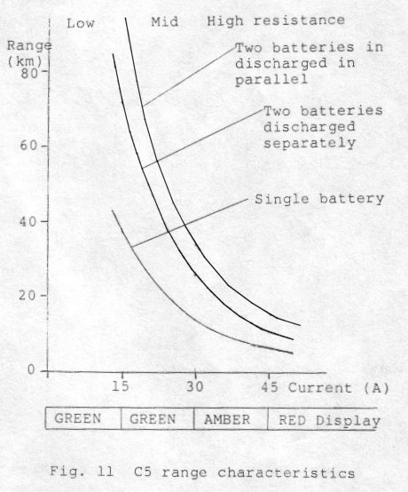

Gradability
In line with its lively acceleration from rest, C5 has basically good hill climbing ability. However, this ability is usually limited in practice by motor thermal conditions. Leaving these limitations aside for the present, Figure 12 shows the theoretical tractive effort available for a wide range of operating conditions, excluding the benefit of any pedal power applied. The figure has been prepared using maximum values of battery voltage and vehicle system efficiencies. (worst-case values would produce a tractive effort line of approximately 75 % the level shown.)
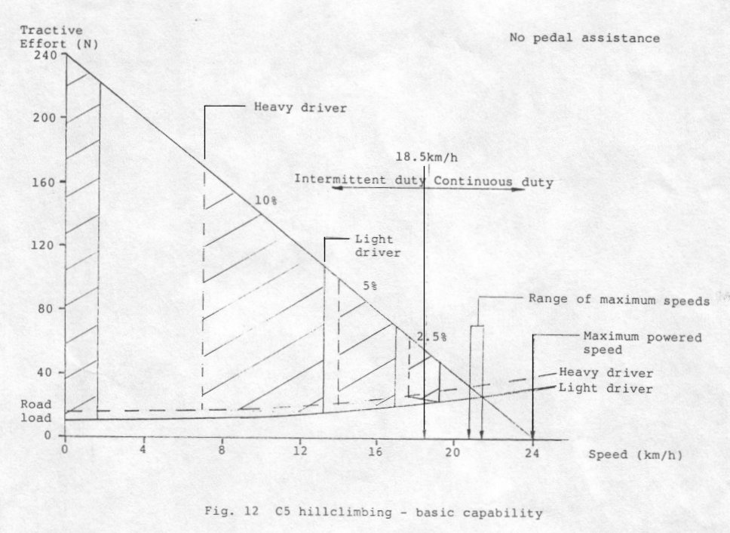

The road load curves are for zero gradient and reflect a value for rolling resistance coefficient of 1% together with aerodynamic characteristics derivedmfrom coast down test results. Both resistance components (rolling and aerodynamic) vary widely in practice, and those used for the figure are "worst-case" values. Tests have indicated a "best-case" rolling and aerodynamic drag resistance coefficients of 60 % of these values.
As indicated in the figure any grade steeper than about 2.5 per cent, and of sufficient length, is likely eventually to induce a thermal cut-out. The question of gradability should therefore always be addressed with regard to the length of the climb as well as his grade. In addition to this, motor temperature at commencement of climb also plays a significant role. For the case of an initially cold motor, without pedal assistance, figures presented previously may be combined to generate a chart which predicts the length of any grade of hill negotiable before thermal cut-out intervenes. Figure 13 shows such a chart for the case of a C5 with a lightweight driver.

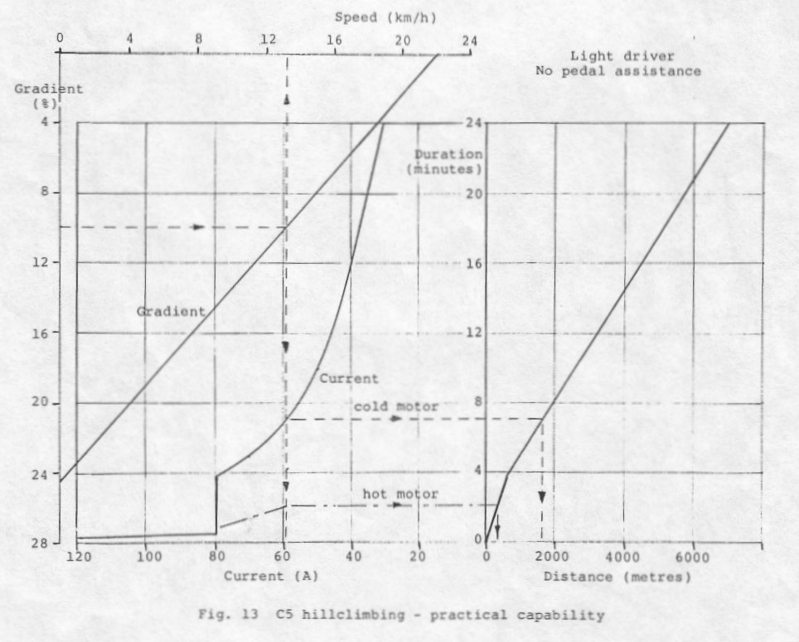
Starting with, for example, a 10 % grade on the left hand ordinate, the dashed lines indicate the flow of information which may be derived from the chart. Thus the speed up the 10 % grade is 13 kilometres per hour, the current drawn is about 60 amps, the duration of climb before thermal shutdown is seven minutes and the length of hill negotiated in this time is about 1500 metres. Other grades may be similarly analysed.
The discontinuity in the current verses time curve in the figure, at 80 amps, represents the transition from the stall sensing circuit to the thermal protection system. This discontinuity is at its greatest for the cold motor condition depicted, and it reduces with increasing motor temperature. A motor already close to its thermal limit at commencement of climb would display virtually no discontinuity as shown by the chain dashed curve, and the length of climb achieved would be greatly reduced, as shown.

Safety Engineering

Primary Safety
The centre of gravity of the C5 with driver installed is approximately 75 % of the wheelbase behind the front wheel. It is also located very low down compared to conventional tricycle configurations, and therefore permits the generation of quite high lateral accelerations before wheel lift occurs. In practice, after familiarity with the vehicle, it is quite easy to achieve "slip before tip" by suitably shifting driver body mass in turns.
The C5 front brake has been engineered to make it difficult to lock the front wheel. By doing so, steering control is maintained at all times, even during the emergency braking. Furthermore, as only one rear wheel is braked, emergency braking involving locking of the rear brake has no tendency to induce a vehicle spin, as is often the case with cars, etc.

Secondary Safety
Although vulnerable to impact by a target vehicle, as is the case for any small, lightweight vehicle, the C5 has been developed to provide its occupant with a high degree of protection from impacts occurring within its own performance spectrum. It has been established in reverse acceleration crash simulation studies at the MIRA Hyge s the led laboratory, that no injury is likely to result from frontal impact into a barrier at any speed up to the C5's own level road maximum. We believe that C5 is the only form of passenger-carrying road vehicle, powered or not, for which this claim may be made.

Notes on C5 Motor/Gearbox Assembly
The motor comprises a cylindrical magnet housing, a ventilated end cap which houses the brushgear and a plastic sleeve/finger assembly that closes off the other end of the cylinder. This plastic assembly which extends back over the cylindrical magnet housing is not of uniform thickness and this allows the motor to be rotated in its circular clamp to adjust the final drive belt tension. Too long through bolts hold the motor together.
The gearbox is a snap fit into a set of "fingers" which form part of the plastic assembly mentioned above. Once clicked into place it is difficult to remove unless all the click features can be unlatched at the same time.
Early plastic assemblies were brown in colour and suffered from a brittle fracture. A pale yellow/white plastic was subsequently used which solved the problem.
To disassembled a complete motor/gearbox, proceed as follows:
1. The brushgear must be lifted to avoid damage as the armature is withdrawn. The black plastic brush holders cannot be easily removed as they have a sprag feature that locks them in place. However, the brushes are held in metal sleeves and these can be pulled out of the holders by applying a steady force. One method is to clamp the junction of the wire and the holder (under its shrink sleeving) in a vice and then to pull on the motor assembly. The brushes should not be fully withdrawn so that their orientation and location remains unchanged.
2. Unscrew and remove the two through bolts.
3. Tap on the exposed end of the motor shaft (brushgear end) using a wooden mallet. This will force the plastic sleeve partially off the end of the cylindrical magnet housing.
4. Continue to pull the plastic assembly clear. It will bring the armature with it.
5. Watch for the two spacers that fit between the end bearing (brushgear end) and the housing. These often flip up and get stuck to the magnets.
6. When totally withdrawn, the armature can be removed from the gearbox by steady pulling. Its end bearings will pull out of the gearbox housing.
7. The gearbox can be taken apart after removal from the plastic finger assembly. The set of shims can be used to open up each finger latch. The whole epicyclic can then be pulled off if necessary.
8. The armature can be skimmed in a lathe if damaged, but the original was diamond turned to achieve a high surface finish and to minimise brush wear.
9. Some form of gearbox lubrication is necessary. Castrol LMB grease is suitable.
10. A common problem is wear of the plastic output pinion due to belt slip. Excessive tightening of the belt can cause the motor to tilt leading to early failure of the pinion. The motor should be held parallel via an upright plastic tongue. This can bow out allowing the motor to tilt. A simple metal plate was made available by Sinclair Vehicles as a retro fit to hold the tongue in place.
11. When reassembling the motor, fit the two spacers into the end cap, crinkle first then plain. Use a wooden rod to push them into place and keep the end cap down to prevent them dropping out and sticking to the magnets again. Guide in the armature and centralise its bearing in the housing by poking through the end cap with a suitable tool. When centered it should drop in cleanly. Note that end cap and the plastic assembly on the other end have features to locate to the magnet sleeve. Get these right during assembly.

Notes on C5 Instrumentation
The C5 instrumentation comprises electronic circuitry contained in two separate parts, viz the instrument pod (IP) and the control box (CB) .
The system provides the following features:
- A fuel gauge comprising a 5 segment bar graph display working on the compensated voltage principle.
- A low battery warning and cut-out to prevent over discharge.
- A motor load indicator comprising a 5 segment bar graph display showing motor current.
- A two-level (motor) temperature measurement system with audio and visual read-out. If the first pre-set temperature threshold is exceeded, both the audio warning and visual flash warning are given. If the second threshold is passed the motor relay is locked out and a visual warning remains.
- Power lock out as indicated above. This is achieved by routing the motor on/off switch via the IP which has control of the relay.
- Stall or heavy overload protection. Circuits in the CB respond to currents over a pre-set threshold and produce a lock out condition dependent on the duration of the overload.

The following description should be read in conjunction with the figures 1 to 4.
Figure 1 - ULA Block Diagram
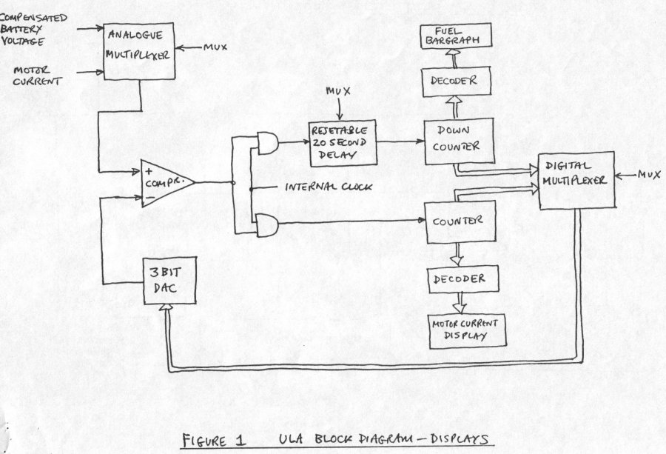
Of the features outlined above, the operation of the two bar graph displays is the central function of the ULA in the IP.
The block diagram shows how this is achieved. Each display is fed from its own counter/decoder. An internal multiplexer is used to timeshare the analogue portions of the ULA comprising digital to analogue converter ( DAC) and front end signal conditioning and level comparator. The multiplexer runs at a variable rate dependent on the conversion time of the motor load current display. A typical sequence is as follows:
- Multiplexer switches to update the motor load display.
- Counter 2 is reset producing zero output from the DAC on to the negative input of the comparator.
- The comparator output is high allowing the internal clock to start counting up, counter 2.
- The DAC output steps up until it equals or exceeds the analogue input on the + of the comparator - this voltage is a function of the motor load current.
- The comparator output changes state and the conversion sequence finishes. The internal multiplexer changes over to update the fuel gauge display.
- The analogue voltage applied to the comparator +ve is a function of the compensated battery voltage.
- The state (count) of the fuel gauge counter is applied to the DAC and hence to the comparator.
- Capitalise first the DAC voltage is higher than the measured voltage, the resettable delay timer starts.
- If the delay times out, the fuel gauge display counter is decremented by one count and the process continues.
- The delay timer is controlled by the multiplexer so that it only responds to the comparator output when the fuel gauge cycle is complete.
In summary, the ULA circuitry is multiplexed to provide sample and held display of motor current and a decrementing display of compensated battery voltage - besides the other functions mentioned in the first section.
Figure 2 - ULA Front End Circuitry
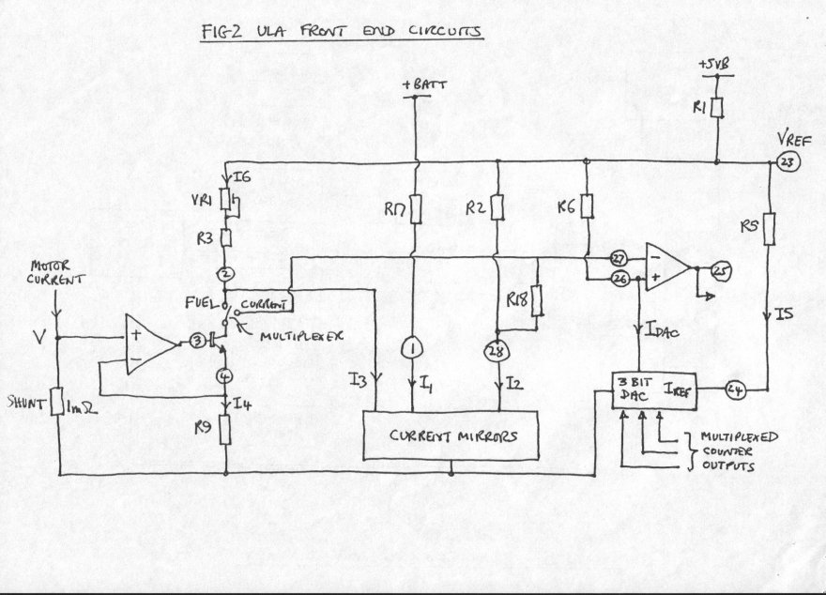
The drawing shows a section of the CB as well as the ULA it internal circuits. An understanding of the relationships between the voltages and currents is necessary if any changes of calibration or application on intended.
Starting with the motor current display mode; the analogue multiplexer switches to the "current" position. The emitter current of transistor 3, I4 is defined by:
I4=V/R9
The current is steered by the multiplexer switch and flows from the Vref rail, through R2 and R18. It produces a voltage drop at pin 27 with respect to pin 23 equal to:
I4(R2+R18)
The DAC is fed with a reference current I5. This is defined by the relationship:
I5=(Vref-1.2)/R5
The least significant bit of the DAC is defined by a:
LSB=I5/I4
if the counter driving the DAC steps up until the DAC output current, Idac, flowing through R6 from the the Vref rail, produces a voltage drop across R6 at pin 26 equal to or greater than that at pin 27. At this point the comparator output changes and the cycle stops. The ULA multiplexer then switches to fuel gauge mode.
In fuel gauge mode, the following events happen. The analogue multiplexer is switched to the "fuel" position. An offset current I6 flows from Vref pin 23 through VR1 and R3 into pin 2 which is at a constant potential of 2 Vbe, i e about 1.2 volts.
I6=(Vref-1.2)/(R3+VR1)
A current proportional to motor current, i e I4 is subtracted from the offset current leaving a nett current I3 flowing into the current mirror.
I3=I6-I4
A current I1 proportional to battery voltage flows through R17.
I1=(Vbatt-0.6)/R17
The mirror circuit sinks a current I2 defined by:
I2=0.5(I1-I3)
Current I2 flows from Vref through R2 producing a offset voltage on pin 27 of the comparator. The comparator output will let the delay timer starts if the DAC output current causes pin 26 to be offset more than pin 27. This will cause the fuel bar graph to eventually decrement by one segment, reducing the DAC output current. Note from equations 2 and 4 that: if
I2=0.5(I1-I6+I4)
This indicates that the fuel gauge reading (its proportional to I2) if is higher if I1 is higher, is offset by I6 and increased by I4 - hence the current compensated offset voltage function for fuel is achieved.
Note that the internal voltage reference at Vref is fed from the +5VB rail via resistor R1.

Figure 3 - Instrument Pod

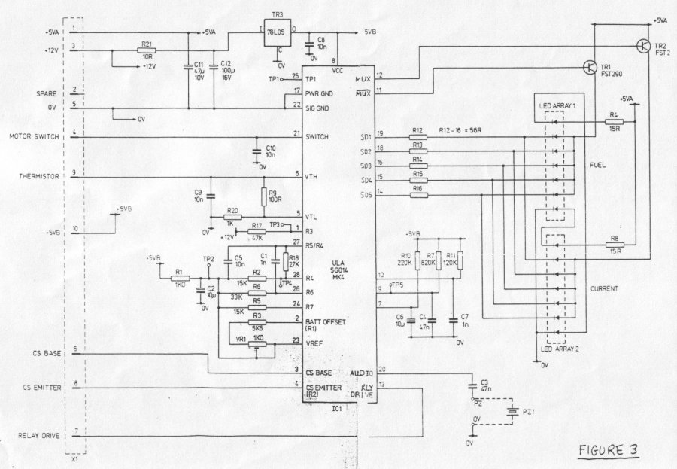
The Ferranti ULA (uncommitted logic array) performs all the key functions. It is powered from a 5 volt supply +5VB derived from the C5 12 volt battery via regulator TR3. This supply is always present so that the state of the fuel gauge is effectively "remembered".
The ULA drives the two bar graphs through a common five line multiplexed bus - SD1 to SD5. TR1 and TR2 provide anode multiplexing. These transistors should have a saturation voltage of less than 0.5 volts at 100 mA collector current and 3.75 mA base current. The FST290 is a specially selected transistor to this specification.
The ULA contains three internal oscillators connected to pins 7, 9 and 10. The approximate frequencies and functions are as follows:
- R10 and C6: 0.4 Hz divided by eight to give 20 second fuel gauge delay timer.
- R7 and C4: 50 Hz divided internally to provide flash rate and fuel gauge lock out time.
- R11 and C7: 9.5 KHz divided by 2 to drive piezo buzzer and internal multiplexer.
A piezo-ceramic buzzer is a.c. coupled to pin 20 to act as the audio warning device.
The +5VA supply is obtained from the regulator in the CB. This supply is only present when the C5 is powered up, thus the displays are only lit in this condition.
The motor switch causes a 12 volt signal routed via a 15 K resistor in the CB to be applied to the ULA pin 21. The ULA drives the motor relay in the CB via a transistor, from pin 13.
The motor temperature thermistor is arranged in a potential divider network across the +5VB supply together with R9 and R20. The ULA pins 5 and 6 are comparator inputs. The threshold voltage on the comparators is set within the ULA to 0.5 Vcc. The two trip levels operate with nominal thermistor resistances of 1100 and 900 Ohms.
The resistor networks associated with pins 1,2,23,24,26,27 and 28 control the analogue front end of the ULA for voltage and current measurement. The pot VR1 is used to trim the effective value of the internal voltage reference and hence to set up the "battery offset". This is the effective no-load battery voltage at which battery cut-off occurs.
ULA pins 3 and 4 are associated with a remote motor current sensor in the CB. The display of motor load current and compensation for battery internal impedance is controlled by the emitter current of the ULA transistor on pin 3 and 4.
Figure 4 - Control Box

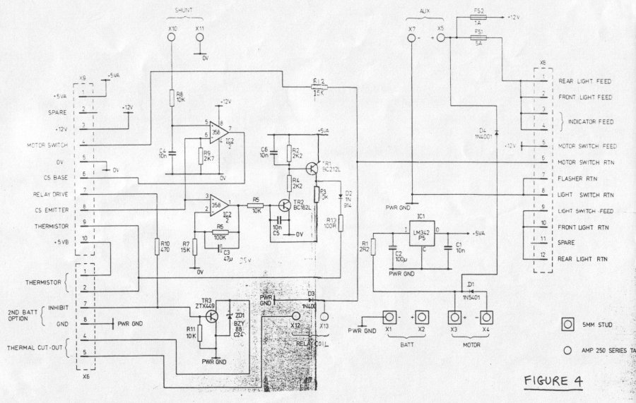
The connector X9 joins to X1 in the IP on a pin for pin basis. X6 provides system inputs for the motor temperature thermistor (pins 1 and 2), the motor over-temperature trip (pins 4 and 5) and a means of providing remote cut-out (pins 7 and 8).
Transistor TR3 drives the relay. The zener diode ZD1 suppresses the transient produced by the relay coil at turn-off. The rapid decay of coil current which the zener produces is vital to minimising the arc on the relay contacts which is commutated by diode D1.
The regulator IC1 provides 5 volts to the IP display and to TR1 etc.
The op-amp IC2 provides two functions. Firstly it converts the motor current shunt signal (1mV/amp) between X10 and X11 into a current sink in conjunction with the ULA transistor on pins 3 and 4. The value of the current is determined by R9. Resistor R8 and C4 provide a filter. Secondly, IC2 provides an amplifier to drive the regenerative pair TR1/TR2 to detect stall. The amplifier provides gain of 100/15 and the output is integrated by C3. If TR2 turns on, which requires about 0.6 volts on IC2 pin 1, TR1 also turns on and latches up TR2, irrespective of IC2 pin 1. The 5 volt signal on the collector of TR1 feeds via D2 and R13 and simulatea a very low value of motor thermistor. The IP interprets this as an overheat and locks-out the relay drive. This stall condition can only be reset by removing the +5VA supply briefly.

Application of C5 instrumentation system to other vehicles
Thermal protection - different values of thermistor can be used by changing R9 and R20 in the IP. The trip voltage levels of the ULA comparator have already been discussed.
Motor load indicator - the calibration of this display is defined by the sum of R2 and R18 in the IP. Also by the current flow in R9 (CB) for a given shunt current.
Stall protection - by varying R6 and R7 (CB) the sensitivity of the stall protection can be changed, whilst C3 controls the time delay.
24 volt systems - with suitably specified components the C5 circuits can be used on a 24 volt system. Changes required are as follows:
Instrument pod
- C 12 - increase voltage rating
- R 17 - double to 94 KOhms for correct fuel gauge operation on a series connected pair of batteries.
Control box
- C2 - increase voltage rating
- IC1 - increase heat sink size
- Relay - add series resistor
Alternatively, the Instrumentation can be run from 12 volts as normal except for the battery sensing input to the ULA via R17.

Reliability
Static discharge can damage the ULA. It is also possible for the LM358 amplifier in the control box to fail. Some simple modifications have been devised to overcome both these shortcomings. They are as follows:
Instrument pod
- Connect a 47 K resistor in series with the track from X1 pin 6 to IC1 pin 3
- Connect catch diodes (IN914) to Vcc and GND on IC1/4
Control box
- Derive power for IC2 (Pin 8) from the +5VA supply instead of the +12v

Instructions for setting up the offset pot VR1 in the instrument pod
Firstly the internal multiplexer must be disabled and forced into fuel gauge mode. This occurs if pin 9 is grounded at power up. The steps are:
- connect ULA pin 9 to pin 22 (GND)
- apply the required battery lock out voltage to +BATT (top of R17). The suggested value is 10.5 volts
- apply +5V to Vcc pin 8
- set I4 to zero by grounding pin 3 for example
- using a high impedance digital volt meter (z greater than one megohm) measure the voltage between pin 23 (+) and pin 27 (-)
- set VR1 for +200 millivolts. If out of range then R3 should be increased by, say 1000 ohms
- turn-off power, remove the short on pin 9 and check fuel gauge operation under normal conditions. Note that with the nominal component values as shown, drop out time per segment is about 20 seconds with two hidden segments beyond the most significant bit.

Known Problems with the C5
- Commutation diode failure. If the vehicle is pushed backwards at anything other than a very slow rate, the motor which is rotating as a generator forces a high current through its commutation diode which then blows open circuit. Without this component, bad arcing will occur at the relay contacts during switching leading to rapid failure.
- Relay contact failure. Generally due to the above. Contacts can weld closed causing a "run away". The emergency battery cut-out is essential to prevent this hazard.
- Electronic component failures in the control box. The LM358 dual OpAmp in the control box can fail, probably due to large voltage transients on the 12 volt battery supply during accidental disconnect.
- Electronic component failures in the pod. Virtually all the circuitry is provided by a single integrated circuit. This chip obviously cannot be repaired. The robustness of the pod can be increased by fitting a resistor of value 10 K Ohms in the lead feeding pin 6.
- If corrosion of contacts in the electronics is noticed then reliability and function could well be compromised.
- The front wheel being plastic can absorb very little braking heat. Softening of the rim followed by inner tube burst out is known. If a steel rim can be found this provides the best solution.
- Rear brake. A tendency to lock on (digital breaks) is obvious. I'm not sure of a cause as I've seen it happen straight after a new brake assembly was fitted. This cannot be due to pin wear and must therefore be some sort of self servo action due to the geometry of the parts.
- Drive belt and pinion wear. Due to slackness or excessive tension. The latter causes the motor to tilt slightly loading one edge of the belt very heavily. Never start the C5 under power but always pedal a little first. The stall torque of the motor is very high and strains the transmission significantly.

Replacement Parts

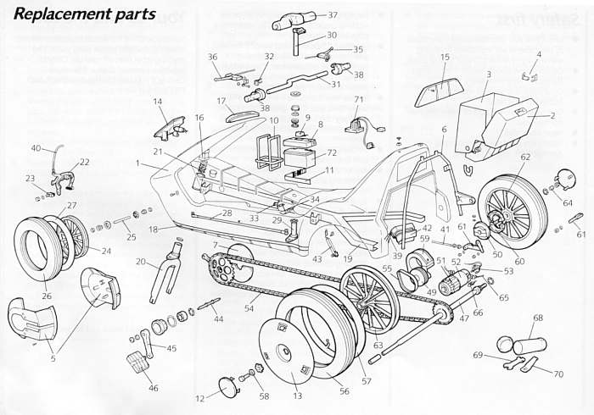

- Bodyshell C5674 300
- Boot Lid C5674 301
- Boot Liner C5674 302
- Boot Lock Set C5674 303
- Front Wheel Cover C5674 304
- Rear Location Frame C5674 305
- Access Covers C5674 306
- Battery Cover Kit C5674 307
- Master security switch assembly C5674 308
- Battery Handling Cradle C5674 309
- Battery Retainer Kit C5674 310
- Rear Wheel Center Cap C5674 311
- Rear Wheel Disc C5674 312
- Front Lamp C5674 313
- Rear Lamp C5674 314
- Bulb Access Housing C5674 315
- Instrument Pod C5674 316
- Decal Kit C5674 317
- Chassis C5674 322
- Front Forks C5674 323
- Steering Bearing Set C5674 324
- Front Brake C5674 325
- Front Brake Blocks C5674 326
- Front Wheel C5674 327
- Front Wheel Spindle Set C5674 328
- Front Tyre C5674 329
- Front Inner Tube C5674 330
- Steering Rod Assembly C5674 331
- Steering Bearing Carrier C5674 332
- Steering Stem C5674 333
- Steering Bars C5674 334
- Power Switch C5674 335
- Lamp Switch C5674 336
- Lamp Switch Bracket C5674 337
- Front Brake Lever C5674 338
- Rear Brake Lever C5674 339
- Steering Bar Cover C5674 340
- Steering Bar Grips C5674 341
- Wiring Harness C5674 342
- Front Brake Cable C5674 343
- Rear Brake Cable C5674 344
- Control Box C5674 345
- Chain Tensioner C5674 346
- Crank Axle C5674 347
- Crank Set C5674 348
- Pedal Set C5674 349
- Rear Axle C5674 351

- Drive Gear C5674 353
- Brake Back Plate C5674 354
- Gearbox C5674 356
- Motor C5674 357
- Heat Sensor C5674 358
- Chain C5674 359
- Drive Belts C5674 360
- Rear Tyre C5674 361
- Rear Inner Tube C5674 362
- LH Wheel Location Set C5674 363
- Motor Support C5674 364
- Rear Brake Shoe Set C5674 365
- Rear Brake Fitting Kit C5674 366
- RH Rear Wheel C5674 367
- LH Rear Wheel C5674 368
- RH Wheel Location Set C5674 369
- Motor Brushes C5674 370
- Thermal Trip C5674 404

- Jack Tube (Vehicle Support) C5674 408
- Battery Securing Nut & Hub
Cone Spanner C5674 407
- Wheel Nut Spanner C5674 406
Fittings Kit Body C5674 319
Fittings Kit Flexibles C5674 318
Fittings Kit Metal C5674 355
Emergancy Kit C5674 372
Tool Kit C5674 373
Contact Cover C5674 387
High Viz Mast C5674 401
- Battery Charger C5674 400
- Battery-Master Security Switch-RH C5674 395

Accessory Instructions

Direction Indicators

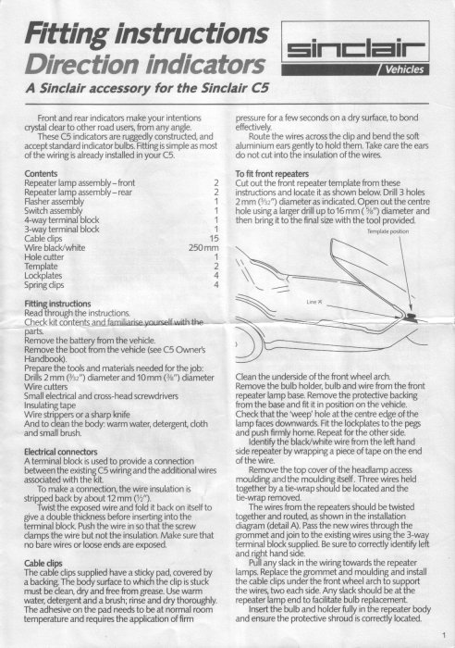
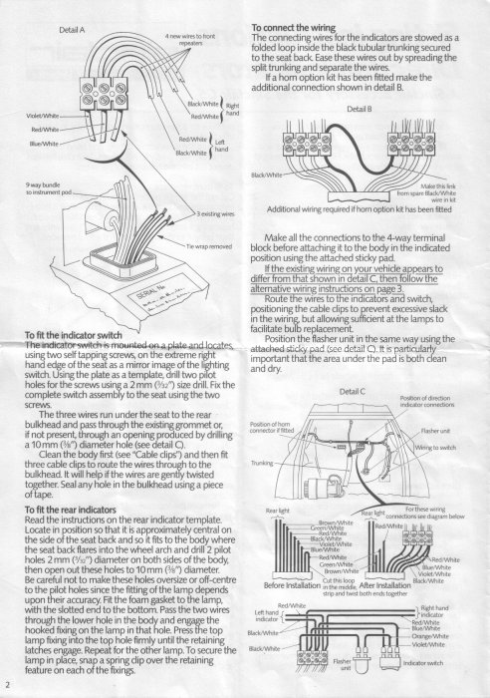

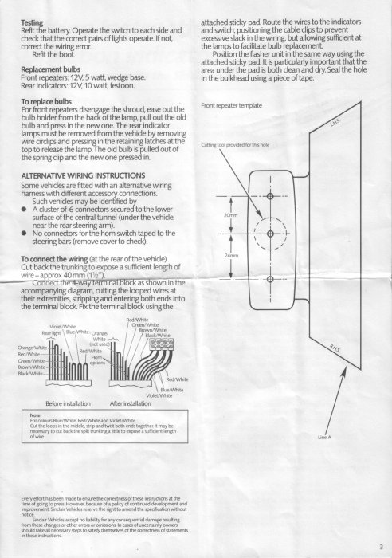

Horn
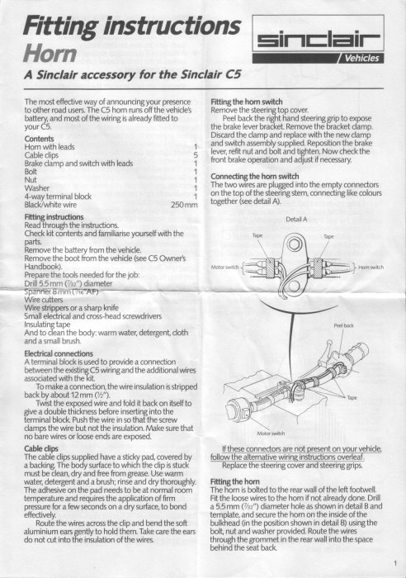

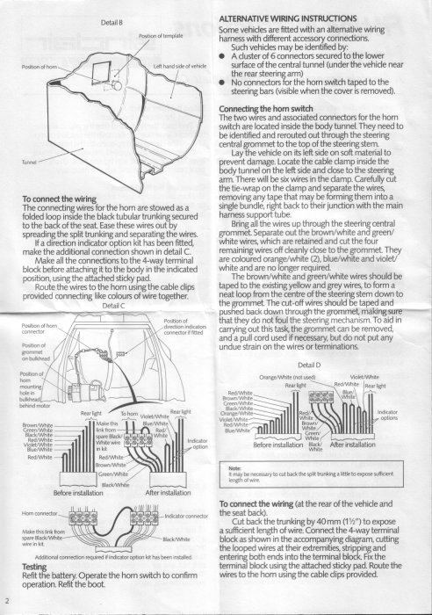

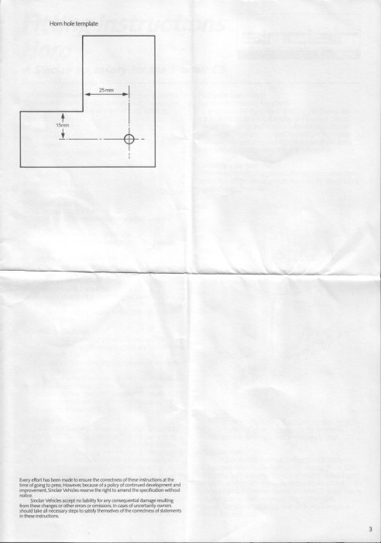

High-Vis Mast

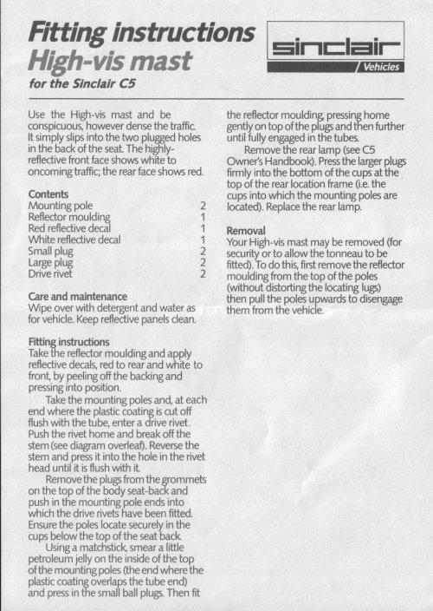
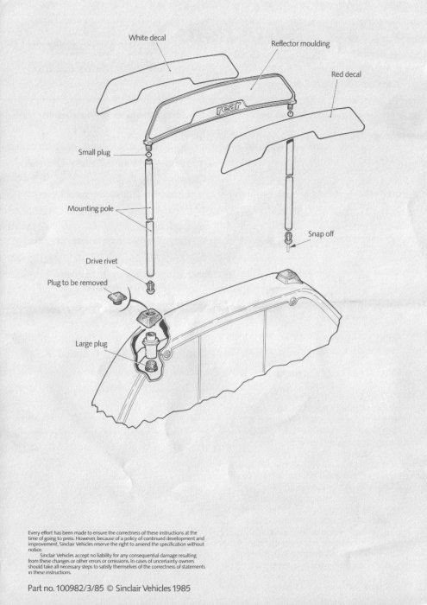

Mirrors

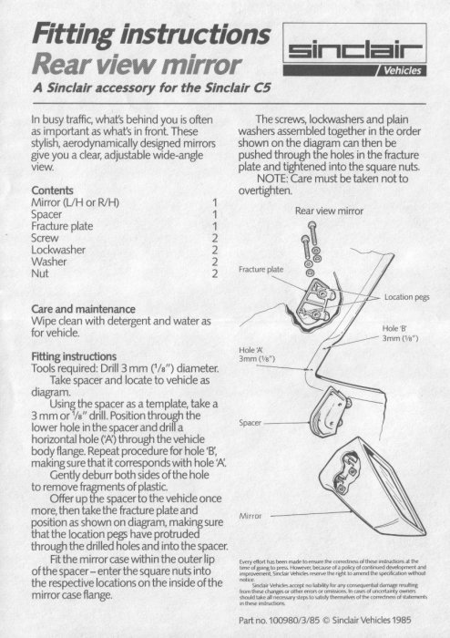

Mud Flaps

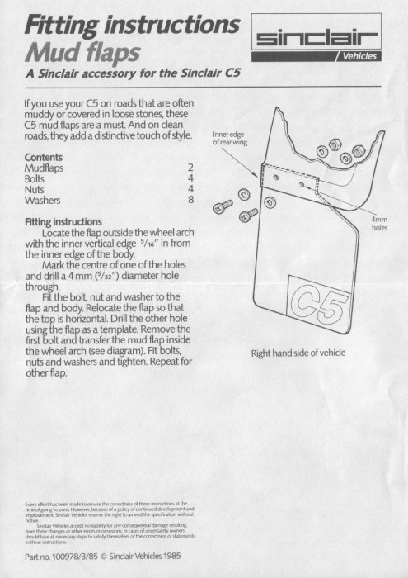

Seat Cushion

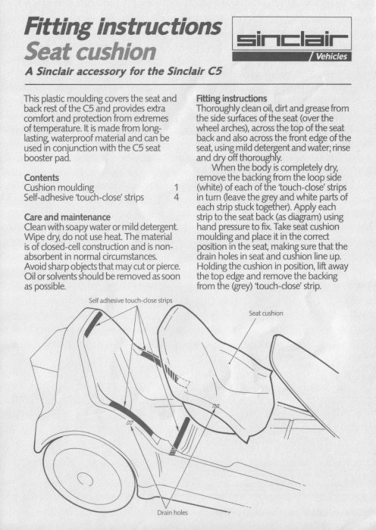


Seat Booster Pad
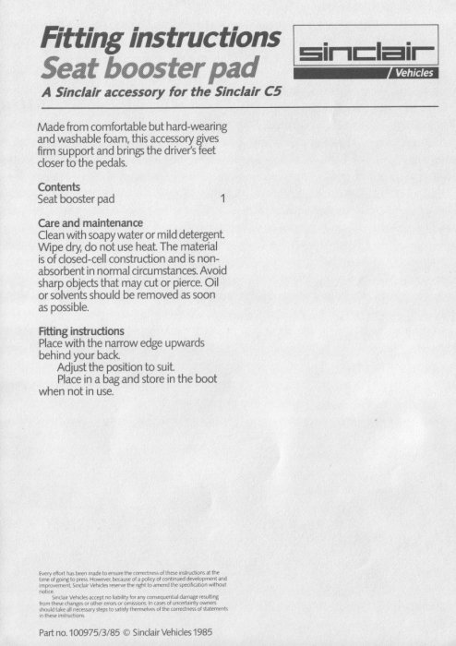

Side Panels
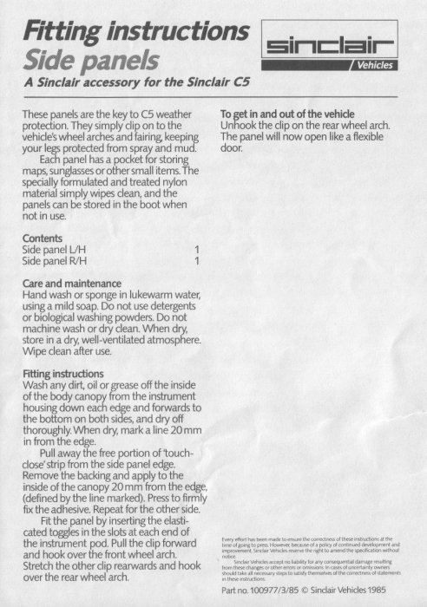

Tonneau


